**LIBRARY MANAGEMENT SYSTEM UML DIAGRAMS**

**J ASHOK REDDY**

**{192011022}**

**1.USE CASE DIAGRAM**

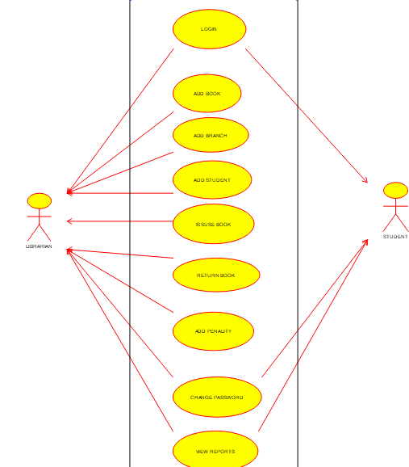

**2.SEQUENCE DIAGRAM**

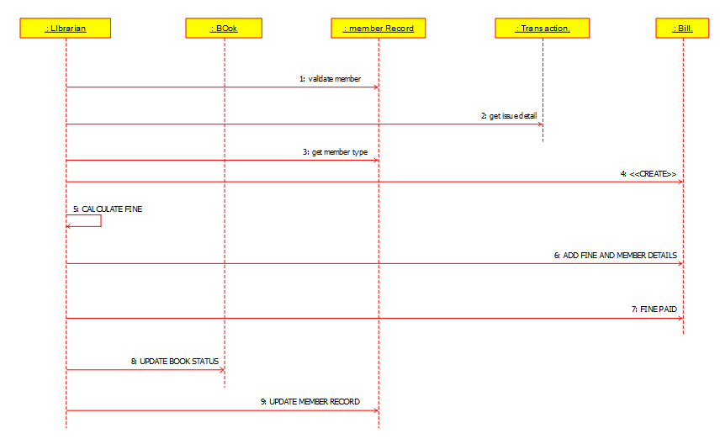

**3.CLASS DIAGRAM**

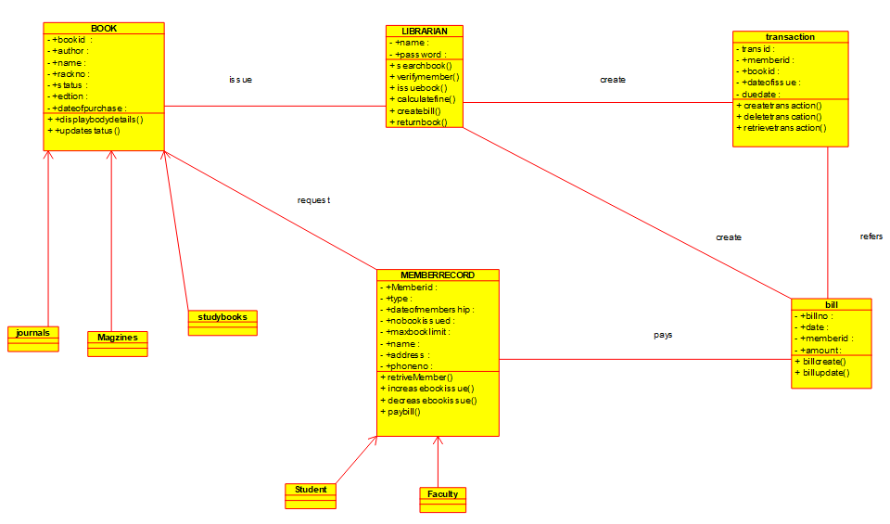

**4.ACTIVITY DIAGRAM**

